PCA-SIMS Spectra Analysis Report

**Samples Included: Soil-Miami-1, Soil-Miami-2, Biofilm-Glass, Biofilm-PTFE, Lignin-Quartz-1400ppm (positive ions)**

ToF-SIMS testing date(s): 1/1/2020, 1/19/2020, 1/28/2023

ToF-SIMS operator(s): Zihua Zhu

# 2D PCA scores plots

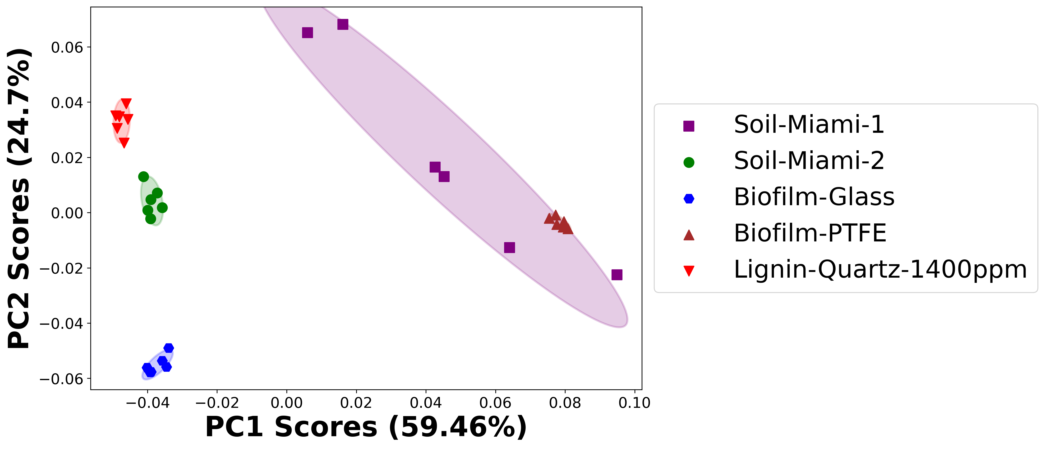

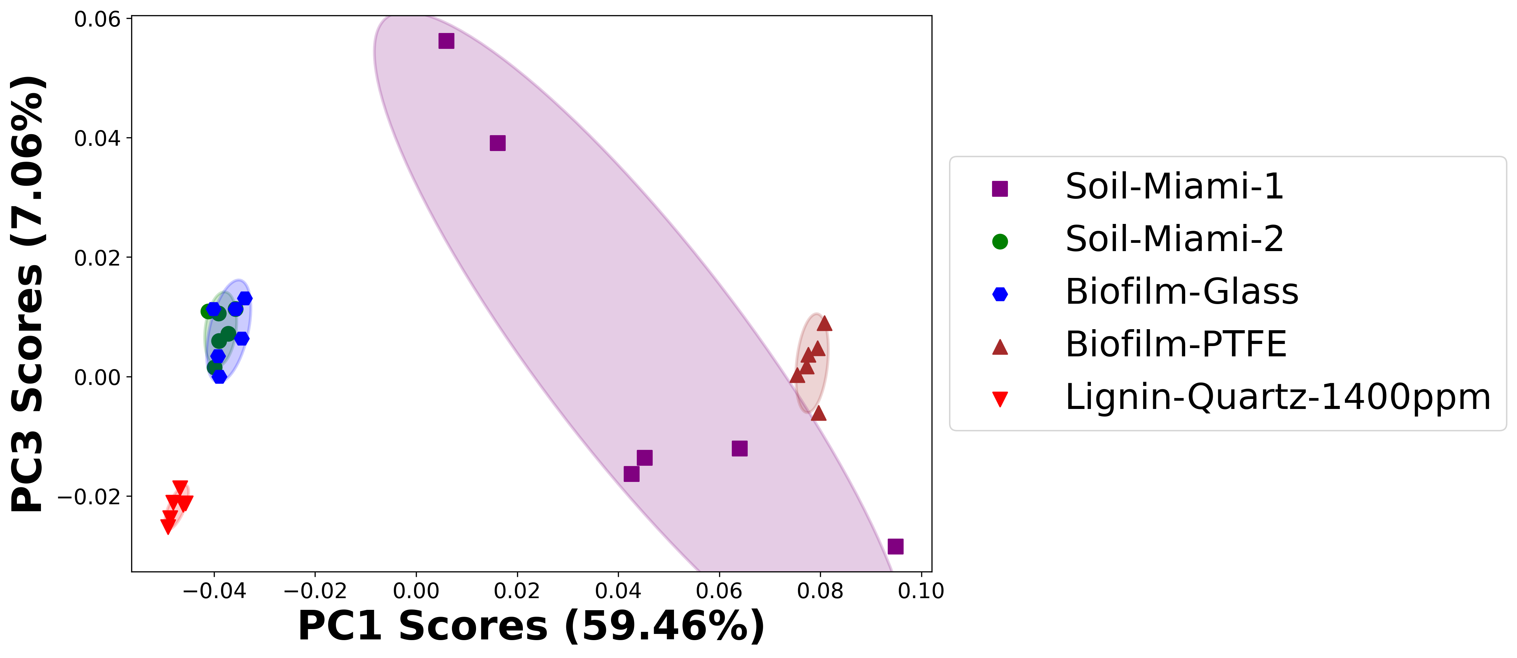

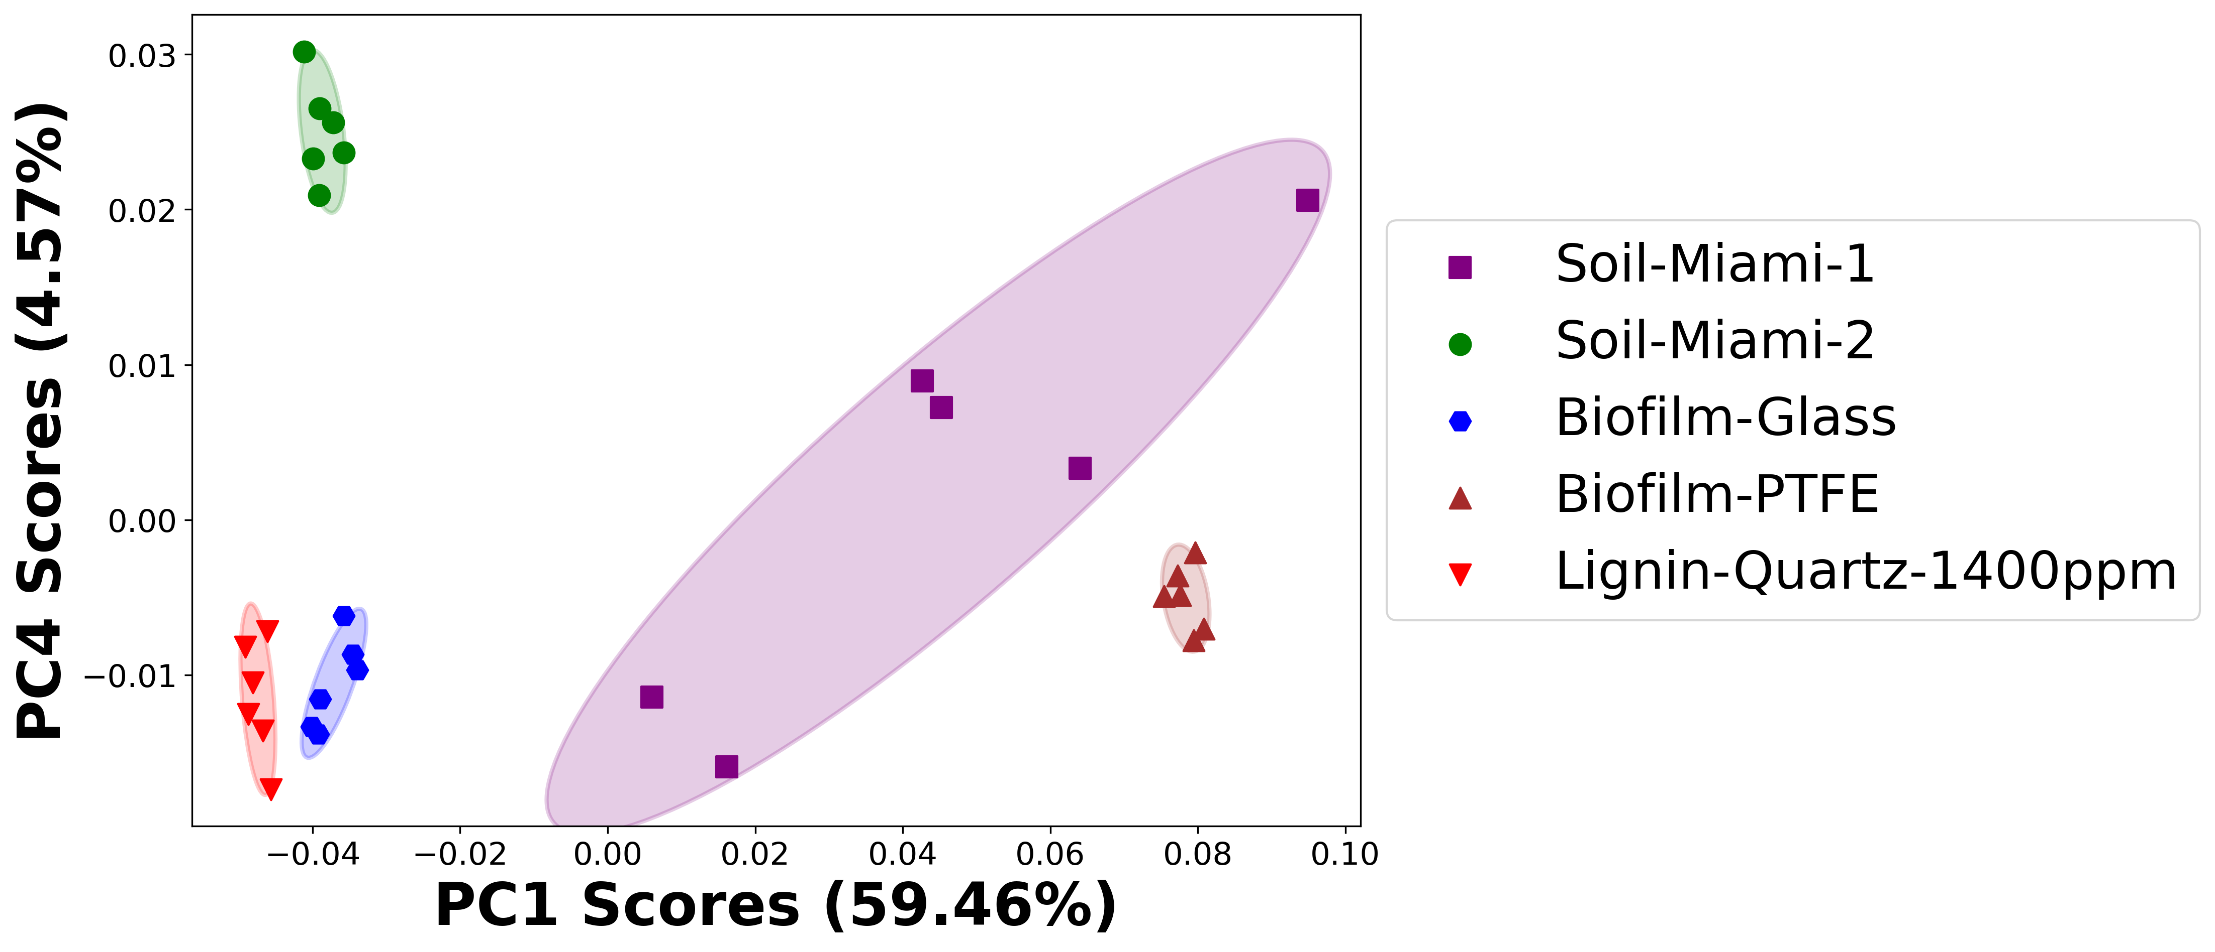

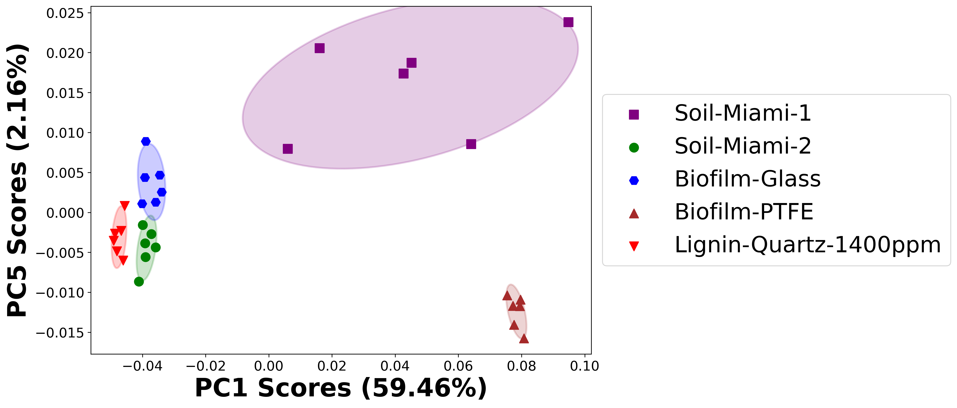

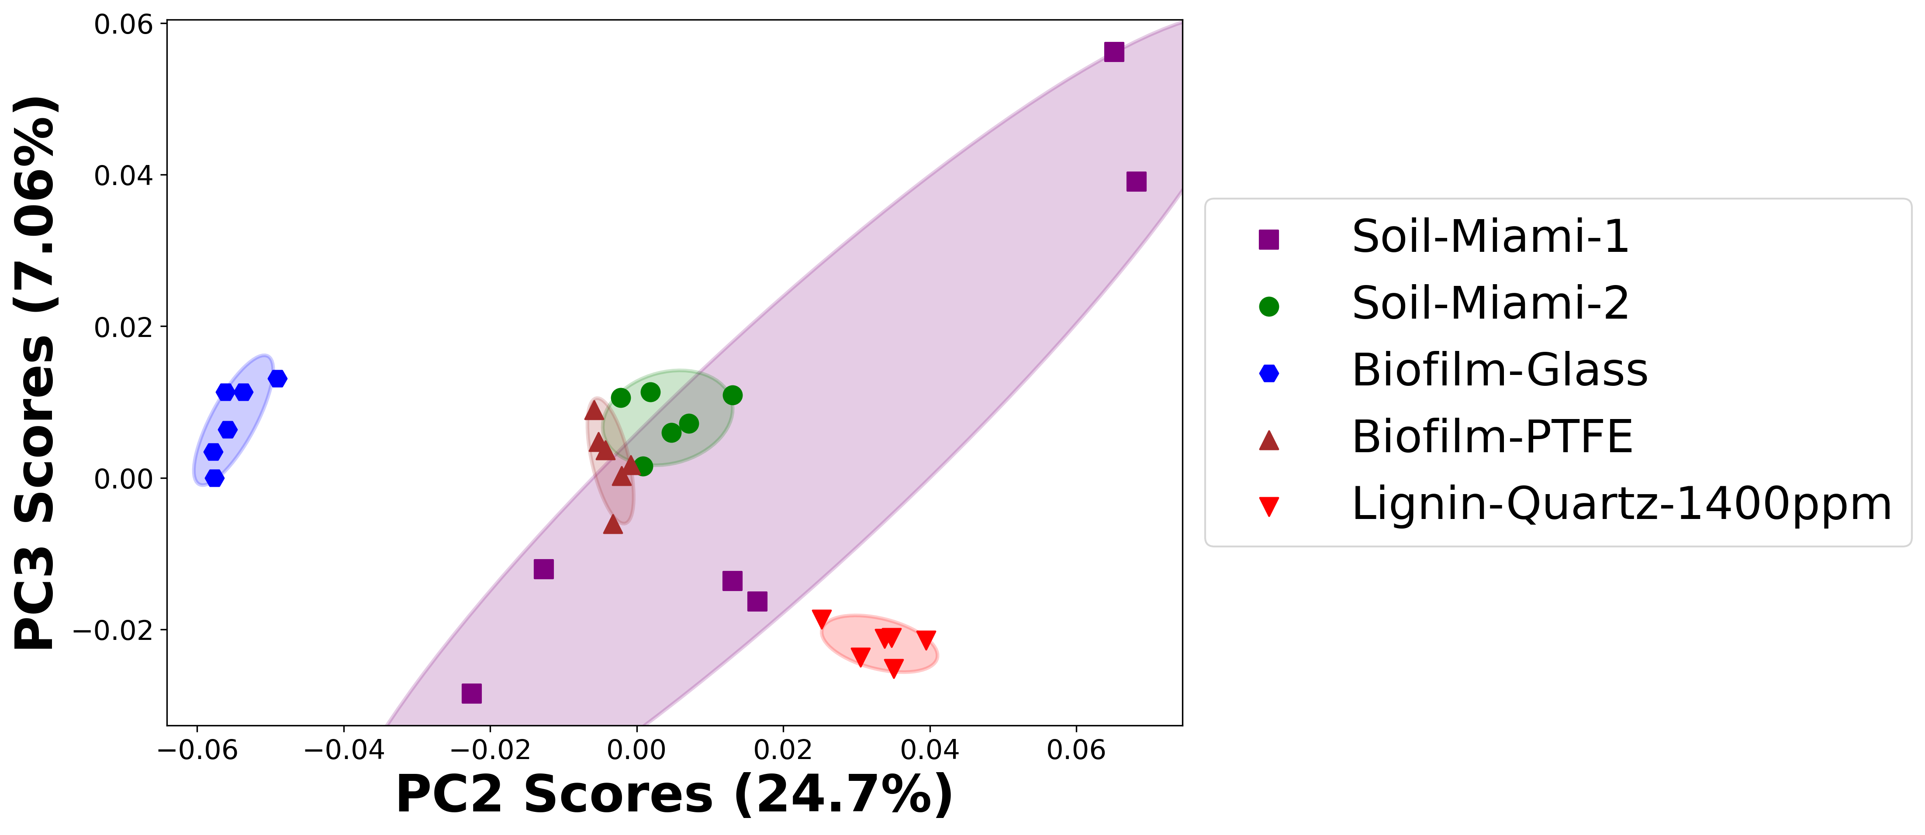

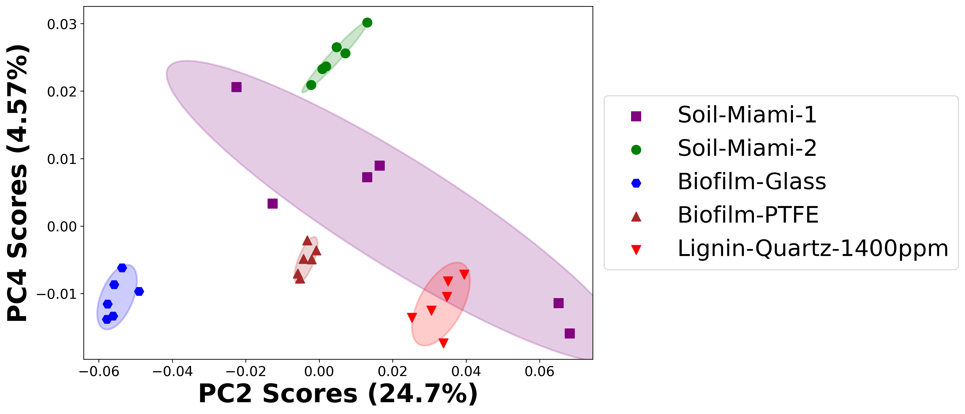

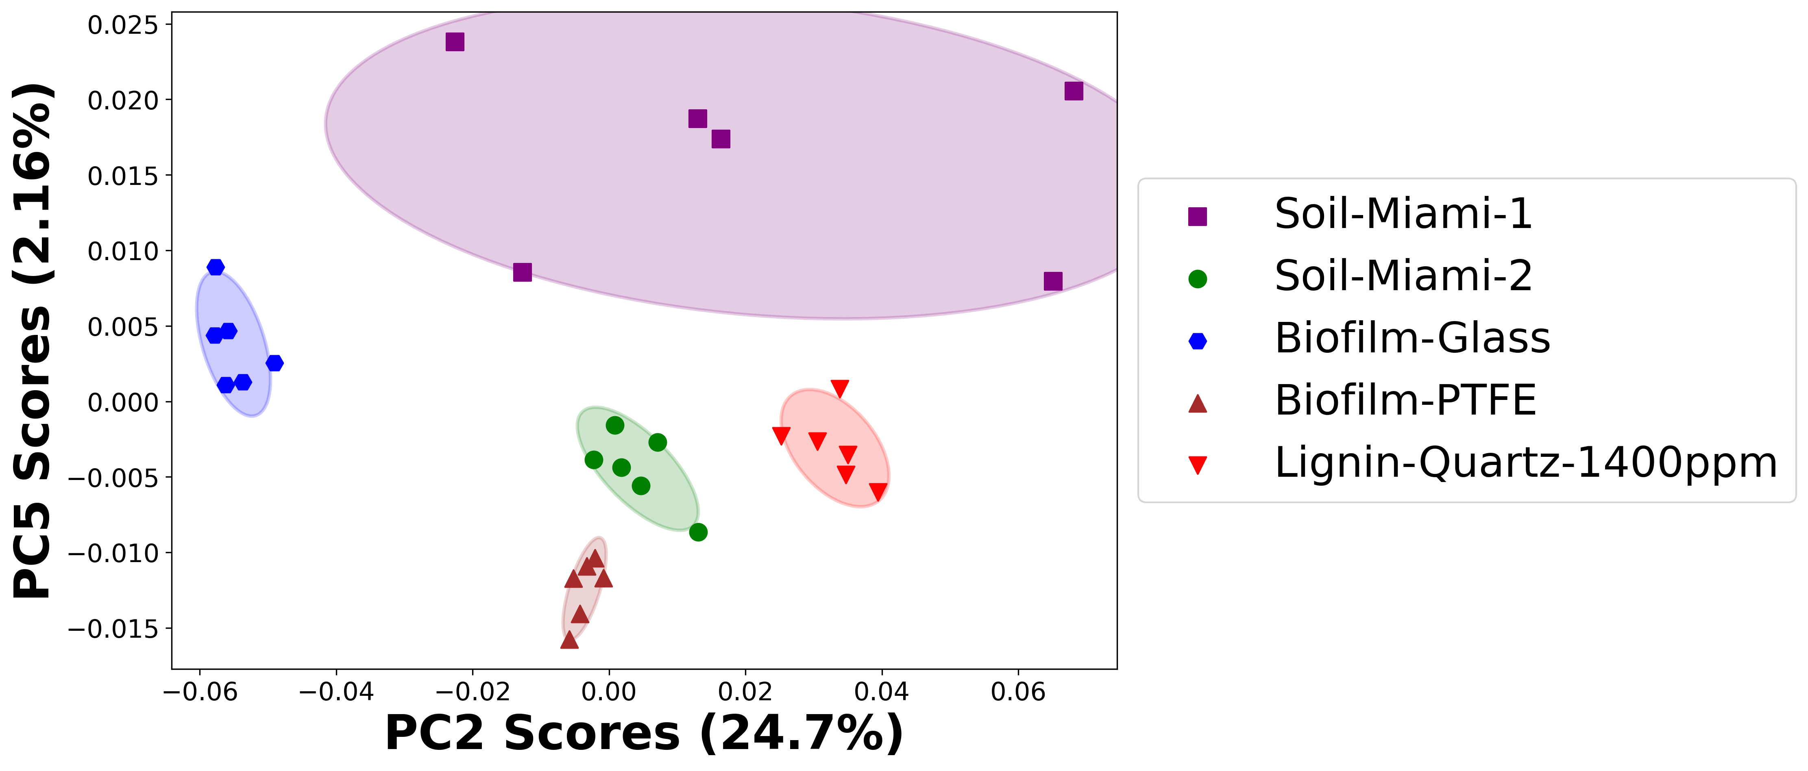

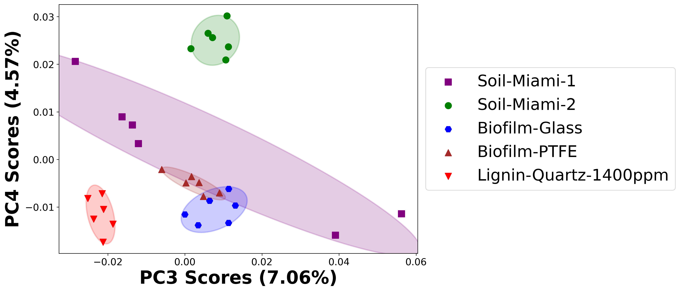

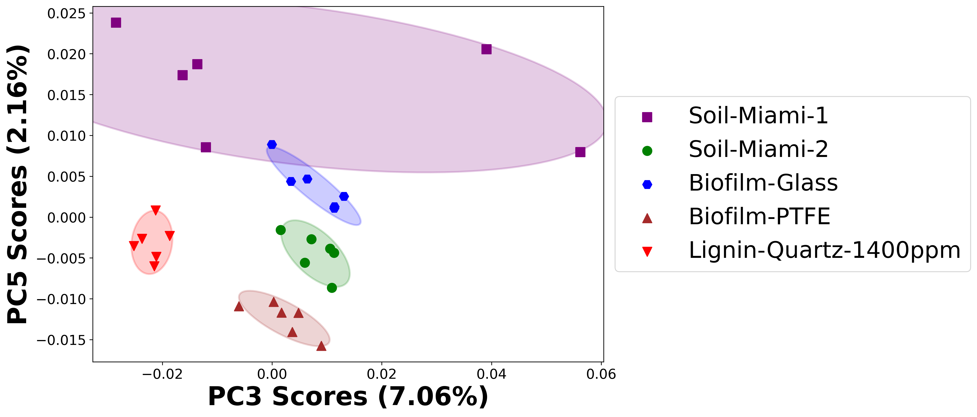

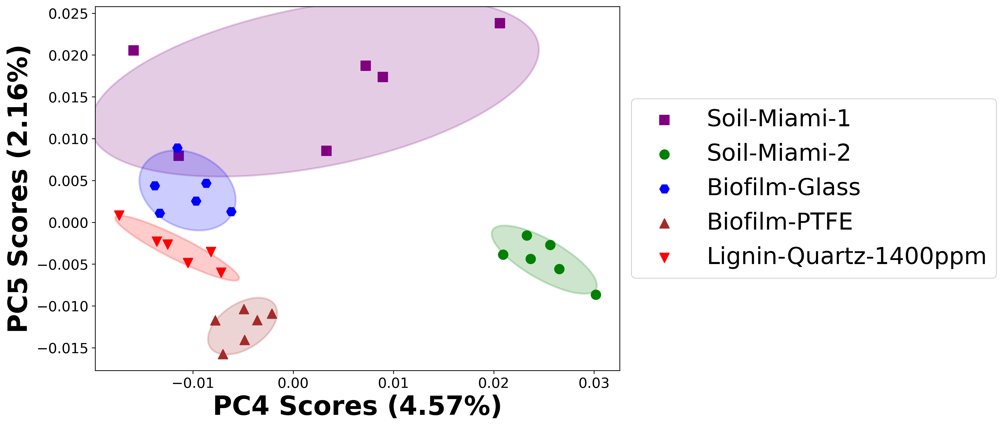

# Positive ion spectra, PCA analysis results -- PC1

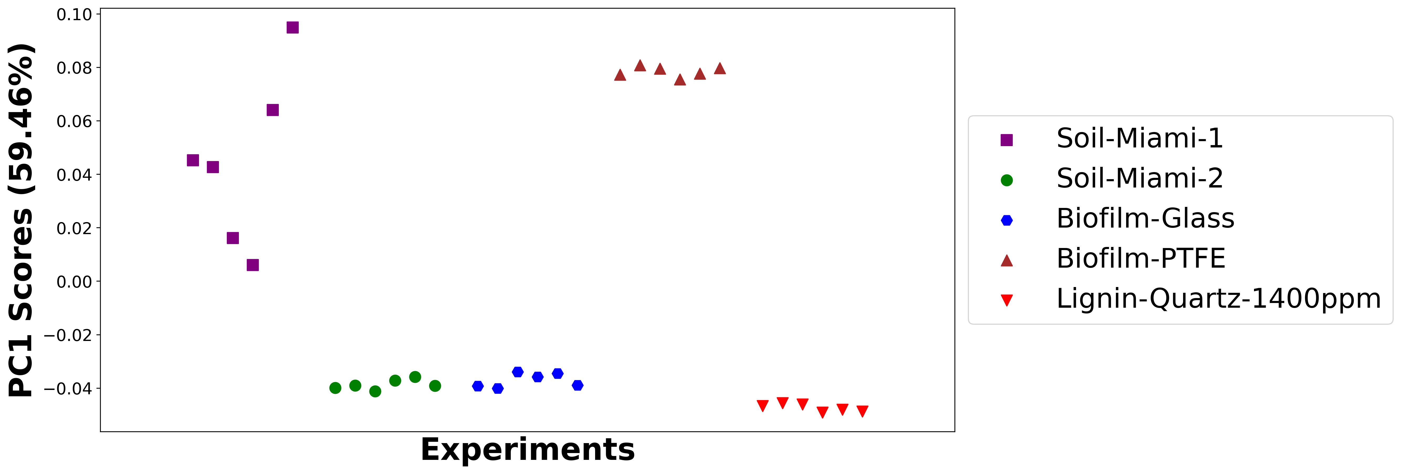

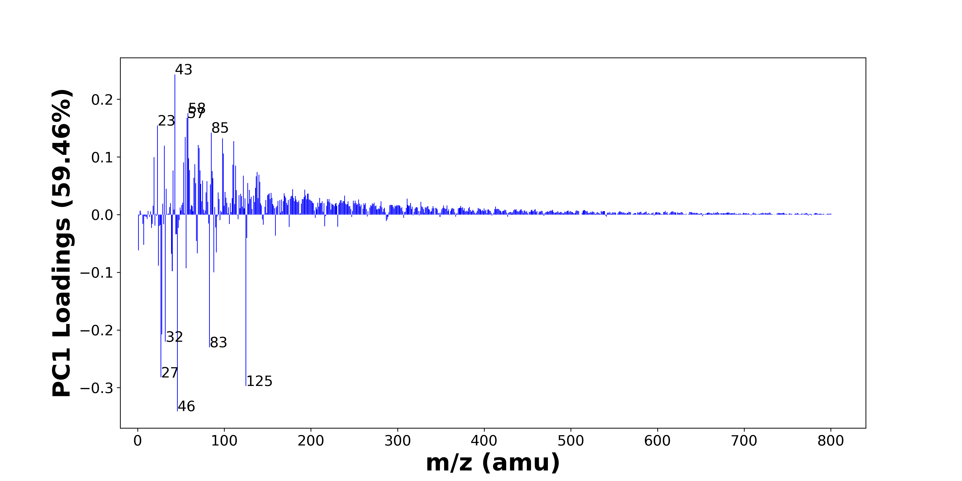

High score samples contain more:

* m/z 43 (C2H5N+, C2H3O+, C3H7+), m/z 58 (C3H8N+, C4H10+), m/z 57 (CaOH+, C4H9+), m/z 23 (Na+), m/z 85 (Na3O+, NaSNO+), m/z 55 (C4H7+, C3H5N+, C2H3N2+), m/z 98 (PO4H3+), m/z 111 (CH3SO4+, SiH3O5+), m/z 70 (C4H8N+, C5H10+), m/z 31 (OCH3+), m/z 71 (C4H7O+, C3H7N2+), m/z 99 (H3SO4+), m/z 19 (OH3+), m/z 59 (), m/z 53 (C4H5+, C3H3N+), m/z 66 (CaCN+), m/z 110 (), m/z 113 (Al3O2+), m/z 60 (C3H10N+, AlO2+), m/z 72 (Si2O+, FeO+, C3H6NO+, C4H10N+)
* Hydrocarbons, Oxygen-containing organics, Nitrogen-containing organics

Low score samples contain more:

* m/z 46 (C2H8N+, Na2+), m/z 125 (C9H17+, C8H15N+), m/z 27 (Al+, C2H3+), m/z 83 (C5H9N+), m/z 32 (CH6N+), m/z 28 (Si+, CH2N+), m/z 88 (C3H10N3+, C5H10O+, C4H10NO+), m/z 40 (Ca+), m/z 56 (56Fe+, C3H6N+), m/z 24 (Mg+), m/z 39 (K+), m/z 69 (C4H7N+), m/z 91 (C3H9NO2+, C7H7+), m/z 1 (H+), m/z 7 (Li+), m/z 68 (C4H6N+), m/z 126 (C8H16N+), m/z 159 (C11H11O+), m/z 44 (C2H6N+, C3H8+), m/z 45 (SiOH+, C2H5O+)
* Benzene-containing organics

# Positive ion spectra, top positive loadings -- PC1

|  |  |  |  |  |  |  |  |  |
| --- | --- | --- | --- | --- | --- | --- | --- | --- |
| + Loading No. | Unit Mass | Document Mass | Initial Peak Assignment | Initial Probabilities | Measured Mass | Peak Assignment (Qualified) | Updated Peak Assignment (from Document Mass) | Updated Document Mass |
| 1 | 43 | 43.0417 43.0178 43.0543 | C2H5N+ C2H3O+ C3H7+ | 0.347 0.331 0.321 | 43.0419 43.0175 43.0540 | C2H5N+ C2H3O+ C3H7+ |  |  |
| 2 | 58 | 58.0651 58.0777 | C3H8N+ C4H10+ | 0.502 0.498 | 58.0732 | C3H8N+ C4H10+ |  |  |
| 3 | 57 | 56.9648 57.0699 | CaOH+ C4H9+ | 0.654 0.346 | 56.9729 | CaOH+ C4H9+ |  |  |
| 4 | 23 | 22.9892 | Na+ | 1.0 | 22.9924 | Na+ |  |  |
| 5 | 85 | 84.9637 84.9593 | Na3O+ NaSNO+ | 0.507 0.493 | 84.9713 | Na3O+ NaSNO+ |  |  |
| 6 | 55 | 55.0543 55.0417 55.0291 | C4H7+ C3H5N+ C2H3N2+ | 0.359 0.333 0.308 | 55.0615 | C4H7+ C3H5N+ C2H3N2+ |  |  |
| 7 | 98 | 97.9763 | PO4H3+ | 1.0 | 97.9805 | PO4H3+ |  |  |
| 8 | 111 | 110.9747 110.9744 | CH3SO4+ SiH3O5+ | 0.501 0.499 | 110.97 | CH3SO4+ SiH3O5+ |  |  |
| 9 | 70 | 70.0652 70.0777 | C4H8N+ C5H10+ | 0.519 0.481 | 70.0761 | C4H8N+ C5H10+ |  |  |
| 10 | 31 | 31.0179 | OCH3+ | 1.0 | 31.0221 | OCH3+ |  |  |
| 11 | 71 | 71.0496 71.0604 | C4H7O+ C3H7N2+ | 0.518 0.482 | 71.0611 | C4H7O+ C3H7N2+ |  |  |
| 12 | 99 | 98.9747 | H3SO4+ | 1.0 |  |  |  |  |
| 13 | 19 | 19.0179 | OH3+ | 1.0 | 19.0207 | OH3+ |  |  |
| 14 | 59 |  |  |  |  |  |  |  |
| 15 | 53 | 53.0386 53.026 | C4H5+ C3H3N+ | 0.519 0.481 |  |  |  |  |
| 16 | 66 | 65.9651 | CaCN+ | 1.0 |  |  |  |  |
| 17 | 110 |  |  |  |  |  |  |  |
| 18 | 113 | 112.9339 | Al3O2+ | 1.0 |  |  |  |  |
| 19 | 60 | 60.0808 59.9708 | C3H10N+ AlO2+ | 0.608 0.392 |  |  |  |  |
| 20 | 72 | 71.9482 71.9293 72.044 72.0808 | Si2O+ FeO+ C3H6NO+ C4H10N+ | 0.322 0.284 0.228 0.165 |  |  |  |  |

Note: Highlighting of the qualified peak assignments represents the error in the document masses relative to the measured mass(es) in that row. Green signifies an error < 100ppm, yellow an error from 100 to 200ppm, and red an error > 200ppm.

# Positive ion spectra, top negative loadings -- PC1

|  |  |  |  |  |  |  |  |  |
| --- | --- | --- | --- | --- | --- | --- | --- | --- |
| - Loading No. | Unit Mass | Document Mass | Initial Peak Assignment | Initial Probabilities | Measured Mass | Peak Assignment (Qualified) | Updated Peak Assignment (from Document Mass) | Updated Document Mass |
| 1 | 46 | 46.0652 45.979 | C2H8N+ Na2+ | 0.651 0.349 | 46.0702 | C2H8N+ Na2+ |  |  |
| 2 | 125 | 125.1325 125.1199 | C9H17+ C8H15N+ | 0.514 0.486 | 125.1289 | C9H17+ C8H15N+ |  |  |
| 3 | 27 | 26.981 27.023 | Al+ C2H3+ | 0.548 0.452 | 26.9853 | Al+ C2H3+ |  |  |
| 4 | 83 | 83.073 | C5H9N+ | 1.0 | 83.0716 | C5H9N+ |  |  |
| 5 | 32 | 32.0645 | CH6N+ | 1.0 | 32.0534 | CH6N+ |  |  |
| 6 | 28 | 27.9764 28.0182 | Si+ CH2N+ | 0.548 0.452 | 27.9798 | Si+ CH2N+ |  |  |
| 7 | 88 | 88.0869 88.0883 88.0757 | C3H10N3+ C5H10O+ C4H10NO+ | 0.34 0.338 0.322 | 88.0867 | C3H10N3+ C5H10O+ C4H10NO+ |  |  |
| 8 | 40 | 39.962 | Ca+ | 1.0 | 39.9589 | Ca+ |  |  |
| 9 | 56 | 55.9344 56.0495 | 56Fe+ C3H6N+ | 0.634 0.366 |  |  |  |  |
| 10 | 24 | 23.9845 | Mg+ | 1.0 | 23.9875 | Mg+ |  |  |
| 11 | 39 | 38.9632 | K+ | 1.0 | 38.9683 | K+ |  |  |
| 12 | 69 | 69.0573 | C4H7N+ | 1.0 | 69.0533 | C4H7N+ |  |  |
| 13 | 91 | 91.0628 91.0543 | C3H9NO2+ C7H7+ | 0.512 0.488 | 91.0656 | C3H9NO2+ C7H7+ |  |  |
| 14 | 1 | 1.0073 | H+ | 1.0 |  |  |  |  |
| 15 | 7 | 7.0155 | Li+ | 1.0 |  |  |  |  |
| 16 | 68 | 68.0495 | C4H6N+ | 1.0 | 68.0467 | C4H6N+ |  |  |
| 17 | 126 | 126.1277 | C8H16N+ | 1.0 | 126.1301 | C8H16N+ |  |  |
| 18 | 159 | 159.0804 | C11H11O+ | 1.0 |  |  |  |  |
| 19 | 44 | 44.0495 44.0621 | C2H6N+ C3H8+ | 0.521 0.479 | 44.0575 | C2H6N+ C3H8+ |  |  |
| 20 | 45 | 44.9792 45.0335 | SiOH+ C2H5O+ | 0.561 0.439 | 44.9846 | SiOH+ C2H5O+ |  |  |

Note: Highlighting of the qualified peak assignments represents the error in the document masses relative to the measured mass(es) in that row. Green signifies an error < 100ppm, yellow an error from 100 to 200ppm, and red an error > 200ppm.

# Positive ion spectra, molecular information from PC1 loadings plot

* The major positive PC1 loadings are m/z 43 (C2H5N+, C2H3O+, C3H7+), m/z 58 (C3H8N+, C4H10+), m/z 57 (CaOH+, C4H9+), m/z 23 (Na+), m/z 85 (Na3O+, NaSNO+), m/z 55 (C4H7+, C3H5N+, C2H3N2+), m/z 98 (PO4H3+), m/z 111 (CH3SO4+, SiH3O5+), m/z 70 (C4H8N+, C5H10+), m/z 31 (OCH3+), m/z 71 (C4H7O+, C3H7N2+), m/z 99 (H3SO4+), m/z 19 (OH3+), m/z 59 (), m/z 53 (C4H5+, C3H3N+), m/z 66 (CaCN+), m/z 110 (), m/z 113 (Al3O2+), m/z 60 (C3H10N+, AlO2+), m/z 72 (Si2O+, FeO+, C3H6NO+, C4H10N+), indicating they are more observed in high PC1 score samples.
* The major negative PC1 loadings are m/z 46 (C2H8N+, Na2+), m/z 125 (C9H17+, C8H15N+), m/z 27 (Al+, C2H3+), m/z 83 (C5H9N+), m/z 32 (CH6N+), m/z 28 (Si+, CH2N+), m/z 88 (C3H10N3+, C5H10O+, C4H10NO+), m/z 40 (Ca+), m/z 56 (56Fe+, C3H6N+), m/z 24 (Mg+), m/z 39 (K+), m/z 69 (C4H7N+), m/z 91 (C3H9NO2+, C7H7+), m/z 1 (H+), m/z 7 (Li+), m/z 68 (C4H6N+), m/z 126 (C8H16N+), m/z 159 (C11H11O+), m/z 44 (C2H6N+, C3H8+), m/z 45 (SiOH+, C2H5O+), indicating they are more observed in low PC1 score samples.
* Hydrocarbons signals, such as m/z 43 (C2H5N+, C2H3O+, C3H7+), m/z 55 (C4H7+, C3H5N+, C2H3N2+), m/z 57 (CaOH+, C4H9+), are mostly found in positive loadings, indicating that high PC1 score samples contain more Hydrocarbons.
* Oxygen-containing organics signals, such as m/z 31 (OCH3+), m/z 19 (OH3+), are mostly found in positive loadings, indicating that high PC1 score samples contain more Oxygen-containing organics.
* Nitrogen-containing organics signals, such as m/z 70 (C4H8N+, C5H10+), are mostly found in positive loadings, indicating that high PC1 score samples contain more Nitrogen-containing organics.
* Benzene-containing organics signals, such as m/z 91 (C3H9NO2+, C7H7+), are mostly found in negative loadings, indicating that low PC1 score samples contain more Benzene-containing organics.

# Positive ion spectra, PCA analysis results -- PC2

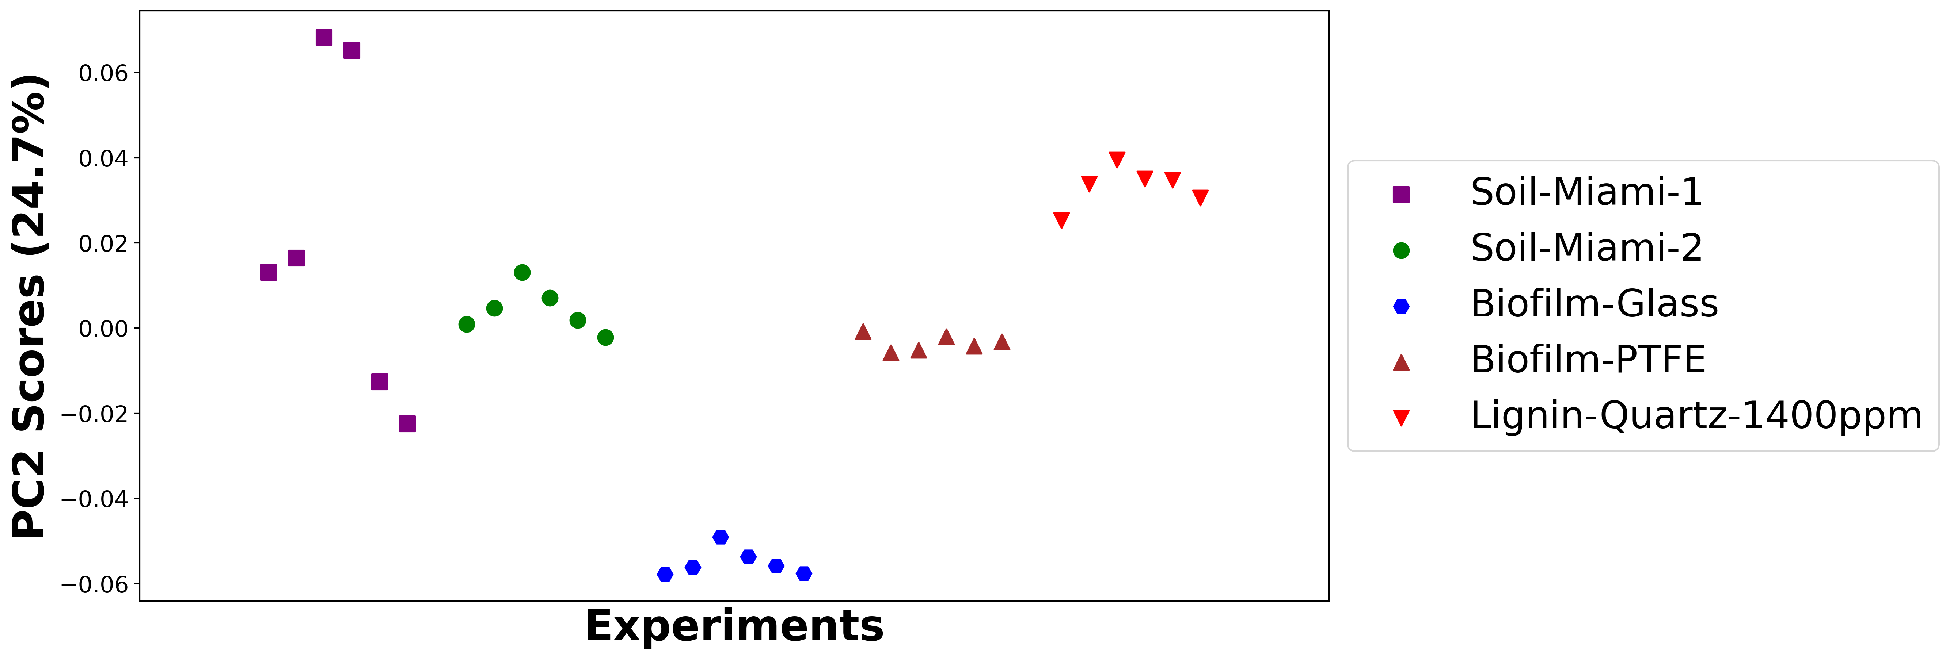

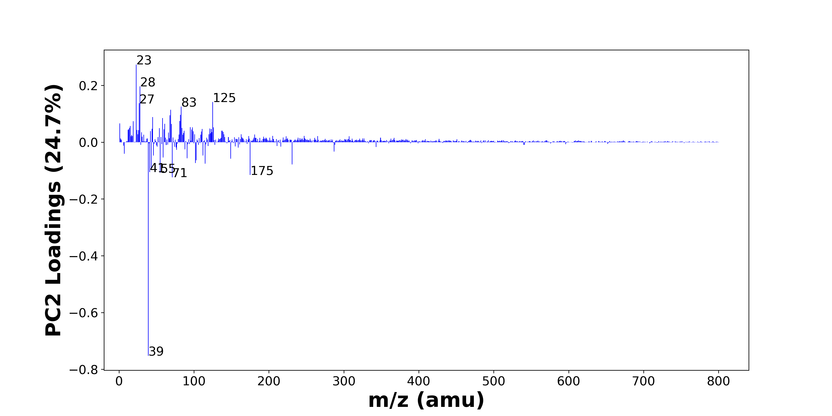

High score samples contain more:

* m/z 23 (Na+), m/z 28 (Si+, CH2N+), m/z 125 (C9H17+, C8H15N+), m/z 27 (Al+, C2H3+), m/z 83 (C5H9N+), m/z 69 (C4H7N+), m/z 82 (C5H8N+), m/z 68 (C4H6N+), m/z 45 (SiOH+, C2H5O+), m/z 58 (C3H8N+, C4H10+), m/z 81 (C5H5O+), m/z 19 (OH3+), m/z 1 (H+), m/z 61 (), m/z 70 (C4H8N+, C5H10+), m/z 15 (CH3+), m/z 95 (), m/z 98 (PO4H3+), m/z 126 (C8H16N+), m/z 14 ()
* Hydrocarbons, Nitrogen-containing organics

Low score samples contain more:

* m/z 39 (K+), m/z 71 (C4H7O+, C3H7N2+), m/z 175 (K2SO4H+, Ca2PO4+), m/z 55 (C4H7+, C3H5N+, C2H3N2+), m/z 41 (C3H5+, 41K+), m/z 43 (C2H5N+, C2H3O+, C3H7+), m/z 231 (Ca3PO5+), m/z 115 (C9H7+, Si4H3+, CH5NFe+), m/z 102 (C6H16N+), m/z 103 (), m/z 149 (C12H5+), m/z 91 (C3H9NO2+, C7H7+), m/z 59 (), m/z 112 (Ca2O2+), m/z 46 (C2H8N+, Na2+), m/z 7 (Li+), m/z 287 (), m/z 77 (C6H5+, C5H3N+), m/z 88 (C3H10N3+, C5H10O+, C4H10NO+), m/z 159 (C11H11O+)
* Benzene-containing organics

# Positive ion spectra, top positive loadings -- PC2

|  |  |  |  |  |  |  |  |  |
| --- | --- | --- | --- | --- | --- | --- | --- | --- |
| + Loading No. | Unit Mass | Document Mass | Initial Peak Assignment | Initial Probabilities | Measured Mass | Peak Assignment (Qualified) | Updated Peak Assignment (from Document Mass) | Updated Document Mass |
| 1 | 23 | 22.9892 | Na+ | 1.0 | 22.9924 | Na+ |  |  |
| 2 | 28 | 27.9764 28.0182 | Si+ CH2N+ | 0.548 0.452 | 27.9798 | Si+ CH2N+ |  |  |
| 3 | 125 | 125.1325 125.1199 | C9H17+ C8H15N+ | 0.514 0.486 | 125.1289 | C9H17+ C8H15N+ |  |  |
| 4 | 27 | 26.981 27.023 | Al+ C2H3+ | 0.548 0.452 | 26.9853 | Al+ C2H3+ |  |  |
| 5 | 83 | 83.073 | C5H9N+ | 1.0 | 83.0716 | C5H9N+ |  |  |
| 6 | 69 | 69.0573 | C4H7N+ | 1.0 | 69.0533 | C4H7N+ |  |  |
| 7 | 82 | 82.0651 | C5H8N+ | 1.0 | 82.0639 | C5H8N+ |  |  |
| 8 | 68 | 68.0495 | C4H6N+ | 1.0 | 68.0467 | C4H6N+ |  |  |
| 9 | 45 | 44.9792 45.0335 | SiOH+ C2H5O+ | 0.561 0.439 | 44.9846 | SiOH+ C2H5O+ |  |  |
| 10 | 58 | 58.0651 58.0777 | C3H8N+ C4H10+ | 0.502 0.498 | 58.0732 | C3H8N+ C4H10+ |  |  |
| 11 | 81 | 81.0335 | C5H5O+ | 1.0 |  |  |  |  |
| 12 | 19 | 19.0179 | OH3+ | 1.0 | 19.0207 | OH3+ |  |  |
| 13 | 1 | 1.0073 | H+ | 1.0 |  |  |  |  |
| 14 | 61 |  |  |  |  |  |  |  |
| 15 | 70 | 70.0652 70.0777 | C4H8N+ C5H10+ | 0.519 0.481 | 70.0761 | C4H8N+ C5H10+ |  |  |
| 16 | 15 | 15.023 | CH3+ | 1.0 |  |  |  |  |
| 17 | 95 |  |  |  |  |  |  |  |
| 18 | 98 | 97.9763 | PO4H3+ | 1.0 | 97.9805 | PO4H3+ |  |  |
| 19 | 126 | 126.1277 | C8H16N+ | 1.0 | 126.1301 | C8H16N+ |  |  |
| 20 | 14 |  |  |  |  |  |  |  |

Note: Highlighting of the qualified peak assignments represents the error in the document masses relative to the measured mass(es) in that row. Green signifies an error < 100ppm, yellow an error from 100 to 200ppm, and red an error > 200ppm.

# Positive ion spectra, top negative loadings -- PC2

|  |  |  |  |  |  |  |  |  |
| --- | --- | --- | --- | --- | --- | --- | --- | --- |
| - Loading No. | Unit Mass | Document Mass | Initial Peak Assignment | Initial Probabilities | Measured Mass | Peak Assignment (Qualified) | Updated Peak Assignment (from Document Mass) | Updated Document Mass |
| 1 | 39 | 38.9632 | K+ | 1.0 | 38.9683 | K+ |  |  |
| 2 | 71 | 71.0496 71.0604 | C4H7O+ C3H7N2+ | 0.518 0.482 | 71.0611 | C4H7O+ C3H7N2+ |  |  |
| 3 | 175 | 174.8864 174.8781 | K2SO4H+ Ca2PO4+ | 0.513 0.487 | 174.9003 | K2SO4H+ Ca2PO4+ |  |  |
| 4 | 55 | 55.0543 55.0417 55.0291 | C4H7+ C3H5N+ C2H3N2+ | 0.359 0.333 0.308 | 55.0615 | C4H7+ C3H5N+ C2H3N2+ |  |  |
| 5 | 41 | 41.0386 40.9613 | C3H5+ 41K+ | 0.618 0.382 | 41.0397 | C3H5+ 41K+ |  |  |
| 6 | 43 | 43.0417 43.0178 43.0543 | C2H5N+ C2H3O+ C3H7+ | 0.347 0.331 0.321 | 43.0419 43.0175 43.0540 | C2H5N+ C2H3O+ C3H7+ |  |  |
| 7 | 231 | 230.8356 | Ca3PO5+ | 1.0 |  |  |  |  |
| 8 | 115 | 115.0543 114.9306 114.9174 | C9H7+ Si4H3+ CH5NFe+ | 0.391 0.322 0.288 |  |  |  |  |
| 9 | 102 | 102.1277 | C6H16N+ | 1.0 |  |  |  |  |
| 10 | 103 |  |  |  |  |  |  |  |
| 11 | 149 | 149.0386 | C12H5+ | 1.0 |  |  |  |  |
| 12 | 91 | 91.0628 91.0543 | C3H9NO2+ C7H7+ | 0.512 0.488 | 91.0656 | C3H9NO2+ C7H7+ |  |  |
| 13 | 59 |  |  |  |  |  |  |  |
| 14 | 112 | 111.9145 | Ca2O2+ | 1.0 |  |  |  |  |
| 15 | 46 | 46.0652 45.979 | C2H8N+ Na2+ | 0.651 0.349 | 46.0702 | C2H8N+ Na2+ |  |  |
| 16 | 7 | 7.0155 | Li+ | 1.0 |  |  |  |  |
| 17 | 287 |  |  |  |  |  |  |  |
| 18 | 77 | 77.0386 77.026 | C6H5+ C5H3N+ | 0.519 0.481 |  |  |  |  |
| 19 | 88 | 88.0869 88.0883 88.0757 | C3H10N3+ C5H10O+ C4H10NO+ | 0.34 0.338 0.322 | 88.0867 | C3H10N3+ C5H10O+ C4H10NO+ |  |  |
| 20 | 159 | 159.0804 | C11H11O+ | 1.0 |  |  |  |  |

Note: Highlighting of the qualified peak assignments represents the error in the document masses relative to the measured mass(es) in that row. Green signifies an error < 100ppm, yellow an error from 100 to 200ppm, and red an error > 200ppm.

# Positive ion spectra, molecular information from PC2 loadings plot

* The major positive PC2 loadings are m/z 23 (Na+), m/z 28 (Si+, CH2N+), m/z 125 (C9H17+, C8H15N+), m/z 27 (Al+, C2H3+), m/z 83 (C5H9N+), m/z 69 (C4H7N+), m/z 82 (C5H8N+), m/z 68 (C4H6N+), m/z 45 (SiOH+, C2H5O+), m/z 58 (C3H8N+, C4H10+), m/z 81 (C5H5O+), m/z 19 (OH3+), m/z 1 (H+), m/z 61 (), m/z 70 (C4H8N+, C5H10+), m/z 15 (CH3+), m/z 95 (), m/z 98 (PO4H3+), m/z 126 (C8H16N+), m/z 14 (), indicating they are more observed in high PC2 score samples.
* The major negative PC2 loadings are m/z 39 (K+), m/z 71 (C4H7O+, C3H7N2+), m/z 175 (K2SO4H+, Ca2PO4+), m/z 55 (C4H7+, C3H5N+, C2H3N2+), m/z 41 (C3H5+, 41K+), m/z 43 (C2H5N+, C2H3O+, C3H7+), m/z 231 (Ca3PO5+), m/z 115 (C9H7+, Si4H3+, CH5NFe+), m/z 102 (C6H16N+), m/z 103 (), m/z 149 (C12H5+), m/z 91 (C3H9NO2+, C7H7+), m/z 59 (), m/z 112 (Ca2O2+), m/z 46 (C2H8N+, Na2+), m/z 7 (Li+), m/z 287 (), m/z 77 (C6H5+, C5H3N+), m/z 88 (C3H10N3+, C5H10O+, C4H10NO+), m/z 159 (C11H11O+), indicating they are more observed in low PC2 score samples.
* Hydrocarbons signals, such as m/z 15 (CH3+), m/z 27 (Al+, C2H3+), are mostly found in positive loadings, indicating that high PC2 score samples contain more Hydrocarbons.
* Nitrogen-containing organics signals, such as m/z 70 (C4H8N+, C5H10+), are mostly found in positive loadings, indicating that high PC2 score samples contain more Nitrogen-containing organics.
* Benzene-containing organics signals, such as m/z 91 (C3H9NO2+, C7H7+), m/z 77 (C6H5+, C5H3N+), m/z 115 (C9H7+, Si4H3+, CH5NFe+), are mostly found in negative loadings, indicating that low PC2 score samples contain more Benzene-containing organics.

# Positive ion spectra, PCA analysis results -- PC3

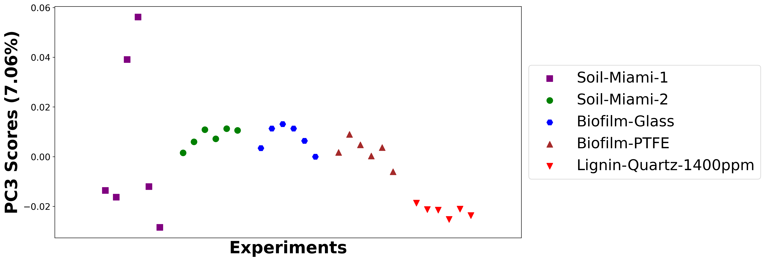

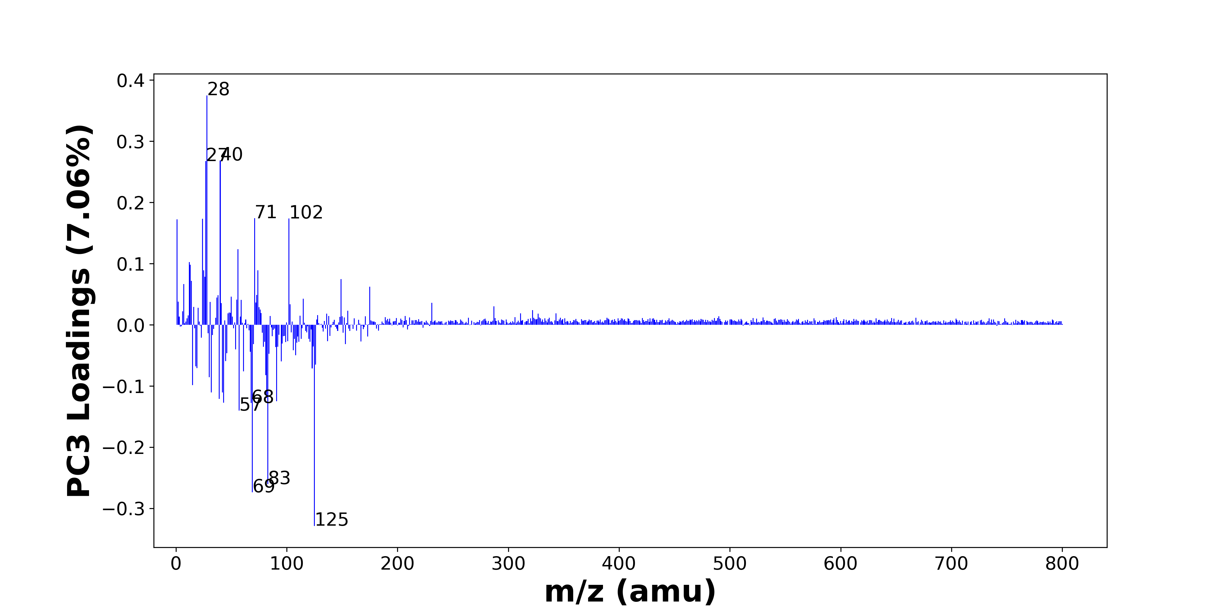

High score samples contain more:

* m/z 28 (Si+, CH2N+), m/z 40 (Ca+), m/z 27 (Al+, C2H3+), m/z 71 (C4H7O+, C3H7N2+), m/z 102 (C6H16N+), m/z 24 (Mg+), m/z 1 (H+), m/z 56 (56Fe+, C3H6N+), m/z 12 (C+), m/z 13 (), m/z 25 (MgH+, 25Mg+), m/z 74 (C4H12N+), m/z 26 (26Mg+), m/z 149 (C12H5+), m/z 14 (), m/z 7 (Li+), m/z 175 (K2SO4H+, Ca2PO4+), m/z 73 (FeOH+, SiC3H9+), m/z 38 (), m/z 50 ()
* PDMS

Low score samples contain more:

* m/z 125 (C9H17+, C8H15N+), m/z 69 (C4H7N+), m/z 83 (C5H9N+), m/z 57 (CaOH+, C4H9+), m/z 68 (C4H6N+), m/z 43 (C2H5N+, C2H3O+, C3H7+), m/z 91 (C3H9NO2+, C7H7+), m/z 39 (K+), m/z 82 (C5H8N+), m/z 42 (C2H4N+), m/z 32 (CH6N+), m/z 15 (CH3+), m/z 30 (CH4N+, 30Si+), m/z 81 (C5H5O+), m/z 61 (), m/z 123 (), m/z 19 (OH3+), m/z 18 (NH4+), m/z 126 (C8H16N+), m/z 95 ()
* Hydrocarbons, Nitrogen-containing organics, Benzene-containing organics

# Positive ion spectra, top positive loadings -- PC3

|  |  |  |  |  |  |  |  |  |
| --- | --- | --- | --- | --- | --- | --- | --- | --- |
| + Loading No. | Unit Mass | Document Mass | Initial Peak Assignment | Initial Probabilities | Measured Mass | Peak Assignment (Qualified) | Updated Peak Assignment (from Document Mass) | Updated Document Mass |
| 1 | 28 | 27.9764 28.0182 | Si+ CH2N+ | 0.548 0.452 | 27.9798 | Si+ CH2N+ |  |  |
| 2 | 40 | 39.962 | Ca+ | 1.0 | 39.9589 | Ca+ |  |  |
| 3 | 27 | 26.981 27.023 | Al+ C2H3+ | 0.548 0.452 | 26.9853 | Al+ C2H3+ |  |  |
| 4 | 71 | 71.0496 71.0604 | C4H7O+ C3H7N2+ | 0.518 0.482 | 71.0611 | C4H7O+ C3H7N2+ |  |  |
| 5 | 102 | 102.1277 | C6H16N+ | 1.0 |  |  |  |  |
| 6 | 24 | 23.9845 | Mg+ | 1.0 | 23.9875 | Mg+ |  |  |
| 7 | 1 | 1.0073 | H+ | 1.0 |  |  |  |  |
| 8 | 56 | 55.9344 56.0495 | 56Fe+ C3H6N+ | 0.634 0.366 |  |  |  |  |
| 9 | 12 | 11.9995 | C+ | 1.0 |  |  |  |  |
| 10 | 13 |  |  |  |  |  |  |  |
| 11 | 25 | 24.9923 24.9853 | MgH+ 25Mg+ | 0.506 0.494 |  |  |  |  |
| 12 | 74 | 74.0964 | C4H12N+ | 1.0 | 74.1054 | C4H12N+ |  |  |
| 13 | 26 | 25.982 | 26Mg+ | 1.0 |  |  |  |  |
| 14 | 149 | 149.0386 | C12H5+ | 1.0 |  |  |  |  |
| 15 | 14 |  |  |  |  |  |  |  |
| 16 | 7 | 7.0155 | Li+ | 1.0 |  |  |  |  |
| 17 | 175 | 174.8864 174.8781 | K2SO4H+ Ca2PO4+ | 0.513 0.487 | 174.9003 | K2SO4H+ Ca2PO4+ |  |  |
| 18 | 73 | 72.9371 73.0469 | FeOH+ SiC3H9+ | 0.645 0.355 | 72.94 | FeOH+ SiC3H9+ |  |  |
| 19 | 38 |  |  |  |  |  |  |  |
| 20 | 50 |  |  |  |  |  |  |  |

Note: Highlighting of the qualified peak assignments represents the error in the document masses relative to the measured mass(es) in that row. Green signifies an error < 100ppm, yellow an error from 100 to 200ppm, and red an error > 200ppm.

# Positive ion spectra, top negative loadings -- PC3

|  |  |  |  |  |  |  |  |  |
| --- | --- | --- | --- | --- | --- | --- | --- | --- |
| - Loading No. | Unit Mass | Document Mass | Initial Peak Assignment | Initial Probabilities | Measured Mass | Peak Assignment (Qualified) | Updated Peak Assignment (from Document Mass) | Updated Document Mass |
| 1 | 125 | 125.1325 125.1199 | C9H17+ C8H15N+ | 0.514 0.486 | 125.1289 | C9H17+ C8H15N+ |  |  |
| 2 | 69 | 69.0573 | C4H7N+ | 1.0 | 69.0533 | C4H7N+ |  |  |
| 3 | 83 | 83.073 | C5H9N+ | 1.0 | 83.0716 | C5H9N+ |  |  |
| 4 | 57 | 56.9648 57.0699 | CaOH+ C4H9+ | 0.654 0.346 | 56.9729 | CaOH+ C4H9+ |  |  |
| 5 | 68 | 68.0495 | C4H6N+ | 1.0 | 68.0467 | C4H6N+ |  |  |
| 6 | 43 | 43.0417 43.0178 43.0543 | C2H5N+ C2H3O+ C3H7+ | 0.347 0.331 0.321 | 43.0419 43.0175 43.0540 | C2H5N+ C2H3O+ C3H7+ |  |  |
| 7 | 91 | 91.0628 91.0543 | C3H9NO2+ C7H7+ | 0.512 0.488 | 91.0656 | C3H9NO2+ C7H7+ |  |  |
| 8 | 39 | 38.9632 | K+ | 1.0 | 38.9683 | K+ |  |  |
| 9 | 82 | 82.0651 | C5H8N+ | 1.0 | 82.0639 | C5H8N+ |  |  |
| 10 | 42 | 42.0338 | C2H4N+ | 1.0 |  |  |  |  |
| 11 | 32 | 32.0645 | CH6N+ | 1.0 | 32.0534 | CH6N+ |  |  |
| 12 | 15 | 15.023 | CH3+ | 1.0 |  |  |  |  |
| 13 | 30 | 30.0339 29.9732 | CH4N+ 30Si+ | 0.601 0.399 |  |  |  |  |
| 14 | 81 | 81.0335 | C5H5O+ | 1.0 |  |  |  |  |
| 15 | 61 |  |  |  |  |  |  |  |
| 16 | 123 |  |  |  |  |  |  |  |
| 17 | 19 | 19.0179 | OH3+ | 1.0 | 19.0207 | OH3+ |  |  |
| 18 | 18 | 18.0339 | NH4+ | 1.0 |  |  |  |  |
| 19 | 126 | 126.1277 | C8H16N+ | 1.0 | 126.1301 | C8H16N+ |  |  |
| 20 | 95 |  |  |  |  |  |  |  |

Note: Highlighting of the qualified peak assignments represents the error in the document masses relative to the measured mass(es) in that row. Green signifies an error < 100ppm, yellow an error from 100 to 200ppm, and red an error > 200ppm.

# Positive ion spectra, molecular information from PC3 loadings plot

* The major positive PC3 loadings are m/z 28 (Si+, CH2N+), m/z 40 (Ca+), m/z 27 (Al+, C2H3+), m/z 71 (C4H7O+, C3H7N2+), m/z 102 (C6H16N+), m/z 24 (Mg+), m/z 1 (H+), m/z 56 (56Fe+, C3H6N+), m/z 12 (C+), m/z 13 (), m/z 25 (MgH+, 25Mg+), m/z 74 (C4H12N+), m/z 26 (26Mg+), m/z 149 (C12H5+), m/z 14 (), m/z 7 (Li+), m/z 175 (K2SO4H+, Ca2PO4+), m/z 73 (FeOH+, SiC3H9+), m/z 38 (), m/z 50 (), indicating they are more observed in high PC3 score samples.
* The major negative PC3 loadings are m/z 125 (C9H17+, C8H15N+), m/z 69 (C4H7N+), m/z 83 (C5H9N+), m/z 57 (CaOH+, C4H9+), m/z 68 (C4H6N+), m/z 43 (C2H5N+, C2H3O+, C3H7+), m/z 91 (C3H9NO2+, C7H7+), m/z 39 (K+), m/z 82 (C5H8N+), m/z 42 (C2H4N+), m/z 32 (CH6N+), m/z 15 (CH3+), m/z 30 (CH4N+, 30Si+), m/z 81 (C5H5O+), m/z 61 (), m/z 123 (), m/z 19 (OH3+), m/z 18 (NH4+), m/z 126 (C8H16N+), m/z 95 (), indicating they are more observed in low PC3 score samples.
* PDMS signals, such as m/z 73 (FeOH+, SiC3H9+), are mostly found in positive loadings, indicating that high PC3 score samples contain more PDMS.
* Hydrocarbons signals, such as m/z 15 (CH3+), m/z 43 (C2H5N+, C2H3O+, C3H7+), m/z 57 (CaOH+, C4H9+), are mostly found in negative loadings, indicating that low PC3 score samples contain more Hydrocarbons.
* Nitrogen-containing organics signals, such as m/z 30 (CH4N+, 30Si+), m/z 18 (NH4+), are mostly found in negative loadings, indicating that low PC3 score samples contain more Nitrogen-containing organics.
* Benzene-containing organics signals, such as m/z 91 (C3H9NO2+, C7H7+), are mostly found in negative loadings, indicating that low PC3 score samples contain more Benzene-containing organics.

# Positive ion spectra, PCA analysis results -- PC4

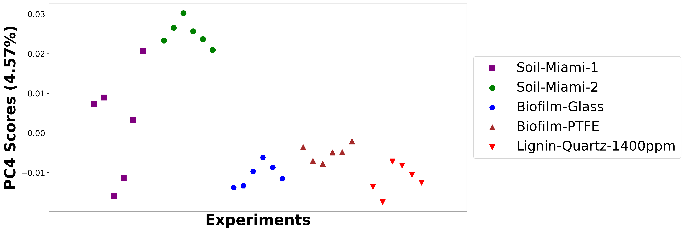

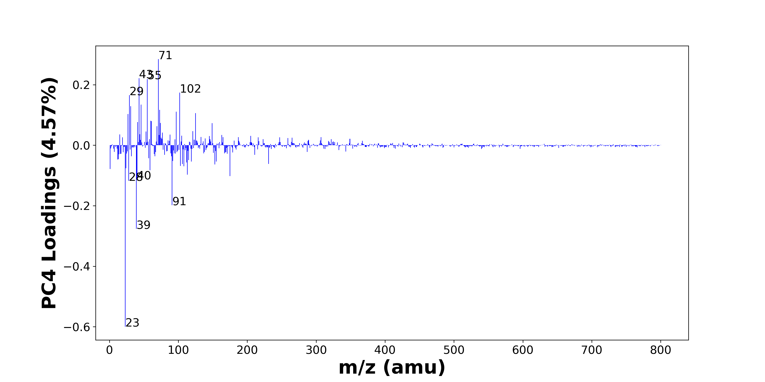

High score samples contain more:

* m/z 71 (C4H7O+, C3H7N2+), m/z 43 (C2H5N+, C2H3O+, C3H7+), m/z 55 (C4H7+, C3H5N+, C2H3N2+), m/z 102 (C6H16N+), m/z 29 (C2H5+, 29Si+), m/z 46 (C2H8N+, Na2+), m/z 31 (OCH3+), m/z 73 (FeOH+, SiC3H9+), m/z 97 (), m/z 125 (C9H17+, C8H15N+), m/z 27 (Al+, C2H3+), m/z 60 (C3H10N+, AlO2+), m/z 61 (), m/z 41 (C3H5+, 41K+), m/z 74 (C4H12N+), m/z 149 (C12H5+), m/z 69 (C4H7N+), m/z 121 (), m/z 53 (C4H5+, C3H3N+), m/z 77 (C6H5+, C5H3N+)
* Hydrocarbons, Oxygen-containing organics, PDMS

Low score samples contain more:

* m/z 23 (Na+), m/z 39 (K+), m/z 91 (C3H9NO2+, C7H7+), m/z 28 (Si+, CH2N+), m/z 40 (Ca+), m/z 175 (K2SO4H+, Ca2PO4+), m/z 113 (Al3O2+), m/z 59 (), m/z 1 (H+), m/z 24 (Mg+), m/z 108 (Na2NO3+), m/z 103 (), m/z 153 (C10H17O+), m/z 106 (), m/z 231 (Ca3PO5+), m/z 112 (Ca2O2+), m/z 155 (), m/z 119 (), m/z 92 (Na2NO2+), m/z 115 (C9H7+, Si4H3+, CH5NFe+)
* Benzene-containing organics

# Positive ion spectra, top positive loadings -- PC4

|  |  |  |  |  |  |  |  |  |
| --- | --- | --- | --- | --- | --- | --- | --- | --- |
| + Loading No. | Unit Mass | Document Mass | Initial Peak Assignment | Initial Probabilities | Measured Mass | Peak Assignment (Qualified) | Updated Peak Assignment (from Document Mass) | Updated Document Mass |
| 1 | 71 | 71.0496 71.0604 | C4H7O+ C3H7N2+ | 0.518 0.482 | 71.0611 | C4H7O+ C3H7N2+ |  |  |
| 2 | 43 | 43.0417 43.0178 43.0543 | C2H5N+ C2H3O+ C3H7+ | 0.347 0.331 0.321 | 43.0419 43.0175 43.0540 | C2H5N+ C2H3O+ C3H7+ |  |  |
| 3 | 55 | 55.0543 55.0417 55.0291 | C4H7+ C3H5N+ C2H3N2+ | 0.359 0.333 0.308 | 55.0615 | C4H7+ C3H5N+ C2H3N2+ |  |  |
| 4 | 102 | 102.1277 | C6H16N+ | 1.0 |  |  |  |  |
| 5 | 29 | 29.0386 28.9759 | C2H5+ 29Si+ | 0.604 0.396 |  |  |  |  |
| 6 | 46 | 46.0652 45.979 | C2H8N+ Na2+ | 0.651 0.349 | 46.0702 | C2H8N+ Na2+ |  |  |
| 7 | 31 | 31.0179 | OCH3+ | 1.0 | 31.0221 | OCH3+ |  |  |
| 8 | 73 | 72.9371 73.0469 | FeOH+ SiC3H9+ | 0.645 0.355 | 72.94 | FeOH+ SiC3H9+ |  |  |
| 9 | 97 |  |  |  |  |  |  |  |
| 10 | 125 | 125.1325 125.1199 | C9H17+ C8H15N+ | 0.514 0.486 | 125.1289 | C9H17+ C8H15N+ |  |  |
| 11 | 27 | 26.981 27.023 | Al+ C2H3+ | 0.548 0.452 | 26.9853 | Al+ C2H3+ |  |  |
| 12 | 60 | 60.0808 59.9708 | C3H10N+ AlO2+ | 0.608 0.392 |  |  |  |  |
| 13 | 61 |  |  |  |  |  |  |  |
| 14 | 41 | 41.0386 40.9613 | C3H5+ 41K+ | 0.618 0.382 | 41.0397 | C3H5+ 41K+ |  |  |
| 15 | 74 | 74.0964 | C4H12N+ | 1.0 | 74.1054 | C4H12N+ |  |  |
| 16 | 149 | 149.0386 | C12H5+ | 1.0 |  |  |  |  |
| 17 | 69 | 69.0573 | C4H7N+ | 1.0 | 69.0533 | C4H7N+ |  |  |
| 18 | 121 |  |  |  |  |  |  |  |
| 19 | 53 | 53.0386 53.026 | C4H5+ C3H3N+ | 0.519 0.481 |  |  |  |  |
| 20 | 77 | 77.0386 77.026 | C6H5+ C5H3N+ | 0.519 0.481 |  |  |  |  |

Note: Highlighting of the qualified peak assignments represents the error in the document masses relative to the measured mass(es) in that row. Green signifies an error < 100ppm, yellow an error from 100 to 200ppm, and red an error > 200ppm.

# Positive ion spectra, top negative loadings -- PC4

|  |  |  |  |  |  |  |  |  |
| --- | --- | --- | --- | --- | --- | --- | --- | --- |
| - Loading No. | Unit Mass | Document Mass | Initial Peak Assignment | Initial Probabilities | Measured Mass | Peak Assignment (Qualified) | Updated Peak Assignment (from Document Mass) | Updated Document Mass |
| 1 | 23 | 22.9892 | Na+ | 1.0 | 22.9924 | Na+ |  |  |
| 2 | 39 | 38.9632 | K+ | 1.0 | 38.9683 | K+ |  |  |
| 3 | 91 | 91.0628 91.0543 | C3H9NO2+ C7H7+ | 0.512 0.488 | 91.0656 | C3H9NO2+ C7H7+ |  |  |
| 4 | 28 | 27.9764 28.0182 | Si+ CH2N+ | 0.548 0.452 | 27.9798 | Si+ CH2N+ |  |  |
| 5 | 40 | 39.962 | Ca+ | 1.0 | 39.9589 | Ca+ |  |  |
| 6 | 175 | 174.8864 174.8781 | K2SO4H+ Ca2PO4+ | 0.513 0.487 | 174.9003 | K2SO4H+ Ca2PO4+ |  |  |
| 7 | 113 | 112.9339 | Al3O2+ | 1.0 |  |  |  |  |
| 8 | 59 |  |  |  |  |  |  |  |
| 9 | 1 | 1.0073 | H+ | 1.0 |  |  |  |  |
| 10 | 24 | 23.9845 | Mg+ | 1.0 | 23.9875 | Mg+ |  |  |
| 11 | 108 | 107.9669 | Na2NO3+ | 1.0 |  |  |  |  |
| 12 | 103 |  |  |  |  |  |  |  |
| 13 | 153 | 153.1274 | C10H17O+ | 1.0 |  |  |  |  |
| 14 | 106 |  |  |  |  |  |  |  |
| 15 | 231 | 230.8356 | Ca3PO5+ | 1.0 |  |  |  |  |
| 16 | 112 | 111.9145 | Ca2O2+ | 1.0 |  |  |  |  |
| 17 | 155 |  |  |  |  |  |  |  |
| 18 | 119 |  |  |  |  |  |  |  |
| 19 | 92 | 91.9719 | Na2NO2+ | 1.0 |  |  |  |  |
| 20 | 115 | 115.0543 114.9306 114.9174 | C9H7+ Si4H3+ CH5NFe+ | 0.391 0.322 0.288 |  |  |  |  |

Note: Highlighting of the qualified peak assignments represents the error in the document masses relative to the measured mass(es) in that row. Green signifies an error < 100ppm, yellow an error from 100 to 200ppm, and red an error > 200ppm.

# Positive ion spectra, molecular information from PC4 loadings plot

* The major positive PC4 loadings are m/z 71 (C4H7O+, C3H7N2+), m/z 43 (C2H5N+, C2H3O+, C3H7+), m/z 55 (C4H7+, C3H5N+, C2H3N2+), m/z 102 (C6H16N+), m/z 29 (C2H5+, 29Si+), m/z 46 (C2H8N+, Na2+), m/z 31 (OCH3+), m/z 73 (FeOH+, SiC3H9+), m/z 97 (), m/z 125 (C9H17+, C8H15N+), m/z 27 (Al+, C2H3+), m/z 60 (C3H10N+, AlO2+), m/z 61 (), m/z 41 (C3H5+, 41K+), m/z 74 (C4H12N+), m/z 149 (C12H5+), m/z 69 (C4H7N+), m/z 121 (), m/z 53 (C4H5+, C3H3N+), m/z 77 (C6H5+, C5H3N+), indicating they are more observed in high PC4 score samples.
* The major negative PC4 loadings are m/z 23 (Na+), m/z 39 (K+), m/z 91 (C3H9NO2+, C7H7+), m/z 28 (Si+, CH2N+), m/z 40 (Ca+), m/z 175 (K2SO4H+, Ca2PO4+), m/z 113 (Al3O2+), m/z 59 (), m/z 1 (H+), m/z 24 (Mg+), m/z 108 (Na2NO3+), m/z 103 (), m/z 153 (C10H17O+), m/z 106 (), m/z 231 (Ca3PO5+), m/z 112 (Ca2O2+), m/z 155 (), m/z 119 (), m/z 92 (Na2NO2+), m/z 115 (C9H7+, Si4H3+, CH5NFe+), indicating they are more observed in low PC4 score samples.
* Hydrocarbons signals, such as m/z 27 (Al+, C2H3+), m/z 29 (C2H5+, 29Si+), m/z 41 (C3H5+, 41K+), m/z 43 (C2H5N+, C2H3O+, C3H7+), m/z 55 (C4H7+, C3H5N+, C2H3N2+), are mostly found in positive loadings, indicating that high PC4 score samples contain more Hydrocarbons.
* Oxygen-containing organics signals, such as m/z 31 (OCH3+), are mostly found in positive loadings, indicating that high PC4 score samples contain more Oxygen-containing organics.
* PDMS signals, such as m/z 73 (FeOH+, SiC3H9+), are mostly found in positive loadings, indicating that high PC4 score samples contain more PDMS.
* Benzene-containing organics signals, such as m/z 91 (C3H9NO2+, C7H7+), m/z 115 (C9H7+, Si4H3+, CH5NFe+), are mostly found in negative loadings, indicating that low PC4 score samples contain more Benzene-containing organics.

# Positive ion spectra, PCA analysis results -- PC5

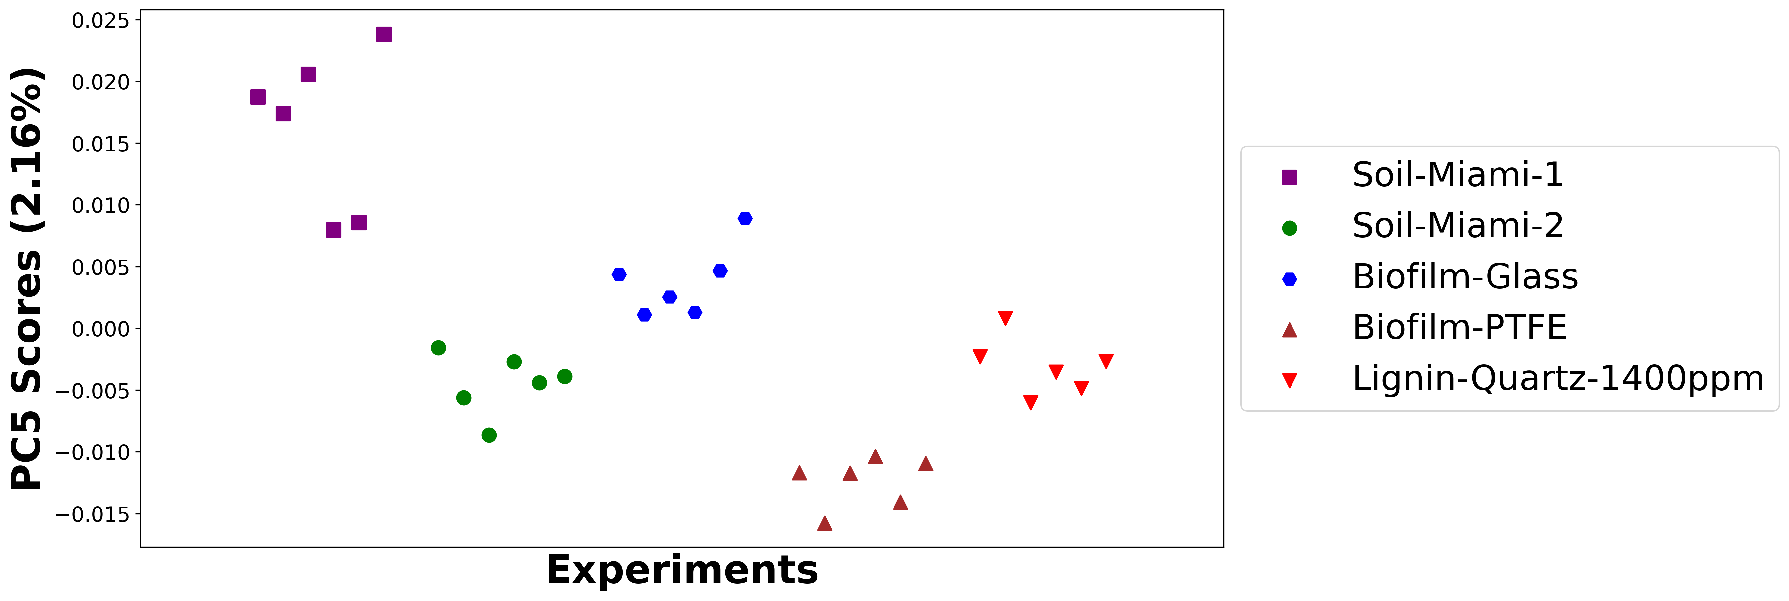

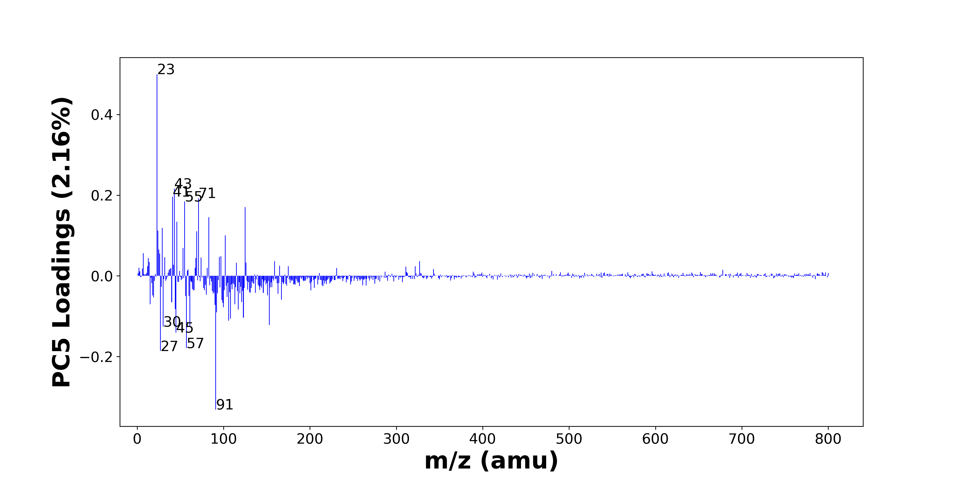

High score samples contain more:

* m/z 23 (Na+), m/z 43 (C2H5N+, C2H3O+, C3H7+), m/z 41 (C3H5+, 41K+), m/z 71 (C4H7O+, C3H7N2+), m/z 55 (C4H7+, C3H5N+, C2H3N2+), m/z 125 (C9H17+, C8H15N+), m/z 83 (C5H9N+), m/z 46 (C2H8N+, Na2+), m/z 29 (C2H5+, 29Si+), m/z 24 (Mg+), m/z 69 (C4H7N+), m/z 102 (C6H16N+), m/z 53 (C4H5+, C3H3N+), m/z 25 (MgH+, 25Mg+), m/z 7 (Li+), m/z 26 (26Mg+), m/z 97 (), m/z 95 (), m/z 32 (CH6N+), m/z 74 (C4H12N+)
* Hydrocarbons

Low score samples contain more:

* m/z 91 (C3H9NO2+, C7H7+), m/z 27 (Al+, C2H3+), m/z 57 (CaOH+, C4H9+), m/z 45 (SiOH+, C2H5O+), m/z 30 (CH4N+, 30Si+), m/z 61 (), m/z 153 (C10H17O+), m/z 106 (), m/z 108 (Na2NO3+), m/z 123 (), m/z 92 (Na2NO2+), m/z 117 (), m/z 44 (C2H6N+, C3H8+), m/z 100 (C4H8N2O+), m/z 90 (C3H10N2O+), m/z 15 (CH3+), m/z 113 (Al3O2+), m/z 99 (H3SO4+), m/z 40 (Ca+), m/z 121 ()
* Nitrogen-containing organics, Benzene-containing organics

# Positive ion spectra, top positive loadings -- PC5

|  |  |  |  |  |  |  |  |  |
| --- | --- | --- | --- | --- | --- | --- | --- | --- |
| + Loading No. | Unit Mass | Document Mass | Initial Peak Assignment | Initial Probabilities | Measured Mass | Peak Assignment (Qualified) | Updated Peak Assignment (from Document Mass) | Updated Document Mass |
| 1 | 23 | 22.9892 | Na+ | 1.0 | 22.9924 | Na+ |  |  |
| 2 | 43 | 43.0417 43.0178 43.0543 | C2H5N+ C2H3O+ C3H7+ | 0.347 0.331 0.321 | 43.0419 43.0175 43.0540 | C2H5N+ C2H3O+ C3H7+ |  |  |
| 3 | 41 | 41.0386 40.9613 | C3H5+ 41K+ | 0.618 0.382 | 41.0397 | C3H5+ 41K+ |  |  |
| 4 | 71 | 71.0496 71.0604 | C4H7O+ C3H7N2+ | 0.518 0.482 | 71.0611 | C4H7O+ C3H7N2+ |  |  |
| 5 | 55 | 55.0543 55.0417 55.0291 | C4H7+ C3H5N+ C2H3N2+ | 0.359 0.333 0.308 | 55.0615 | C4H7+ C3H5N+ C2H3N2+ |  |  |
| 6 | 125 | 125.1325 125.1199 | C9H17+ C8H15N+ | 0.514 0.486 | 125.1289 | C9H17+ C8H15N+ |  |  |
| 7 | 83 | 83.073 | C5H9N+ | 1.0 | 83.0716 | C5H9N+ |  |  |
| 8 | 46 | 46.0652 45.979 | C2H8N+ Na2+ | 0.651 0.349 | 46.0702 | C2H8N+ Na2+ |  |  |
| 9 | 29 | 29.0386 28.9759 | C2H5+ 29Si+ | 0.604 0.396 |  |  |  |  |
| 10 | 24 | 23.9845 | Mg+ | 1.0 | 23.9875 | Mg+ |  |  |
| 11 | 69 | 69.0573 | C4H7N+ | 1.0 | 69.0533 | C4H7N+ |  |  |
| 12 | 102 | 102.1277 | C6H16N+ | 1.0 |  |  |  |  |
| 13 | 53 | 53.0386 53.026 | C4H5+ C3H3N+ | 0.519 0.481 |  |  |  |  |
| 14 | 25 | 24.9923 24.9853 | MgH+ 25Mg+ | 0.506 0.494 |  |  |  |  |
| 15 | 7 | 7.0155 | Li+ | 1.0 |  |  |  |  |
| 16 | 26 | 25.982 | 26Mg+ | 1.0 |  |  |  |  |
| 17 | 97 |  |  |  |  |  |  |  |
| 18 | 95 |  |  |  |  |  |  |  |
| 19 | 32 | 32.0645 | CH6N+ | 1.0 | 32.0534 | CH6N+ |  |  |
| 20 | 74 | 74.0964 | C4H12N+ | 1.0 | 74.1054 | C4H12N+ |  |  |

Note: Highlighting of the qualified peak assignments represents the error in the document masses relative to the measured mass(es) in that row. Green signifies an error < 100ppm, yellow an error from 100 to 200ppm, and red an error > 200ppm.

# Positive ion spectra, top negative loadings -- PC5

|  |  |  |  |  |  |  |  |  |
| --- | --- | --- | --- | --- | --- | --- | --- | --- |
| - Loading No. | Unit Mass | Document Mass | Initial Peak Assignment | Initial Probabilities | Measured Mass | Peak Assignment (Qualified) | Updated Peak Assignment (from Document Mass) | Updated Document Mass |
| 1 | 91 | 91.0628 91.0543 | C3H9NO2+ C7H7+ | 0.512 0.488 | 91.0656 | C3H9NO2+ C7H7+ |  |  |
| 2 | 27 | 26.981 27.023 | Al+ C2H3+ | 0.548 0.452 | 26.9853 | Al+ C2H3+ |  |  |
| 3 | 57 | 56.9648 57.0699 | CaOH+ C4H9+ | 0.654 0.346 | 56.9729 | CaOH+ C4H9+ |  |  |
| 4 | 45 | 44.9792 45.0335 | SiOH+ C2H5O+ | 0.561 0.439 | 44.9846 | SiOH+ C2H5O+ |  |  |
| 5 | 30 | 30.0339 29.9732 | CH4N+ 30Si+ | 0.601 0.399 |  |  |  |  |
| 6 | 61 |  |  |  |  |  |  |  |
| 7 | 153 | 153.1274 | C10H17O+ | 1.0 |  |  |  |  |
| 8 | 106 |  |  |  |  |  |  |  |
| 9 | 108 | 107.9669 | Na2NO3+ | 1.0 |  |  |  |  |
| 10 | 123 |  |  |  |  |  |  |  |
| 11 | 92 | 91.9719 | Na2NO2+ | 1.0 |  |  |  |  |
| 12 | 117 |  |  |  |  |  |  |  |
| 13 | 44 | 44.0495 44.0621 | C2H6N+ C3H8+ | 0.521 0.479 | 44.0575 | C2H6N+ C3H8+ |  |  |
| 14 | 100 | 100.0631 | C4H8N2O+ | 1.0 |  |  |  |  |
| 15 | 90 | 90.0788 | C3H10N2O+ | 1.0 |  |  |  |  |
| 16 | 15 | 15.023 | CH3+ | 1.0 |  |  |  |  |
| 17 | 113 | 112.9339 | Al3O2+ | 1.0 |  |  |  |  |
| 18 | 99 | 98.9747 | H3SO4+ | 1.0 |  |  |  |  |
| 19 | 40 | 39.962 | Ca+ | 1.0 | 39.9589 | Ca+ |  |  |
| 20 | 121 |  |  |  |  |  |  |  |

Note: Highlighting of the qualified peak assignments represents the error in the document masses relative to the measured mass(es) in that row. Green signifies an error < 100ppm, yellow an error from 100 to 200ppm, and red an error > 200ppm.

# Positive ion spectra, molecular information from PC5 loadings plot

* The major positive PC5 loadings are m/z 23 (Na+), m/z 43 (C2H5N+, C2H3O+, C3H7+), m/z 41 (C3H5+, 41K+), m/z 71 (C4H7O+, C3H7N2+), m/z 55 (C4H7+, C3H5N+, C2H3N2+), m/z 125 (C9H17+, C8H15N+), m/z 83 (C5H9N+), m/z 46 (C2H8N+, Na2+), m/z 29 (C2H5+, 29Si+), m/z 24 (Mg+), m/z 69 (C4H7N+), m/z 102 (C6H16N+), m/z 53 (C4H5+, C3H3N+), m/z 25 (MgH+, 25Mg+), m/z 7 (Li+), m/z 26 (26Mg+), m/z 97 (), m/z 95 (), m/z 32 (CH6N+), m/z 74 (C4H12N+), indicating they are more observed in high PC5 score samples.
* The major negative PC5 loadings are m/z 91 (C3H9NO2+, C7H7+), m/z 27 (Al+, C2H3+), m/z 57 (CaOH+, C4H9+), m/z 45 (SiOH+, C2H5O+), m/z 30 (CH4N+, 30Si+), m/z 61 (), m/z 153 (C10H17O+), m/z 106 (), m/z 108 (Na2NO3+), m/z 123 (), m/z 92 (Na2NO2+), m/z 117 (), m/z 44 (C2H6N+, C3H8+), m/z 100 (C4H8N2O+), m/z 90 (C3H10N2O+), m/z 15 (CH3+), m/z 113 (Al3O2+), m/z 99 (H3SO4+), m/z 40 (Ca+), m/z 121 (), indicating they are more observed in low PC5 score samples.
* Hydrocarbons signals, such as m/z 29 (C2H5+, 29Si+), m/z 41 (C3H5+, 41K+), m/z 43 (C2H5N+, C2H3O+, C3H7+), m/z 55 (C4H7+, C3H5N+, C2H3N2+), are mostly found in positive loadings, indicating that high PC5 score samples contain more Hydrocarbons.
* Nitrogen-containing organics signals, such as m/z 30 (CH4N+, 30Si+), m/z 44 (C2H6N+, C3H8+), are mostly found in negative loadings, indicating that low PC5 score samples contain more Nitrogen-containing organics.
* Benzene-containing organics signals, such as m/z 91 (C3H9NO2+, C7H7+), are mostly found in negative loadings, indicating that low PC5 score samples contain more Benzene-containing organics.

